Tenda MW5s-Connection type is PPPoE, dynamic IP is recommended by APP. What should I do?

If you can confirm your connection type is PPPoE, please follow the steps:

Step 1: Power off and power on both MW5s and modem.
Step 2: Reconnect MW5s WiFi, close and reopen Tenda App, reconfigure by following the instruction.

If the problem still exists, please follow the steps:

Step 1: Tap “Choose your connection type manually”.

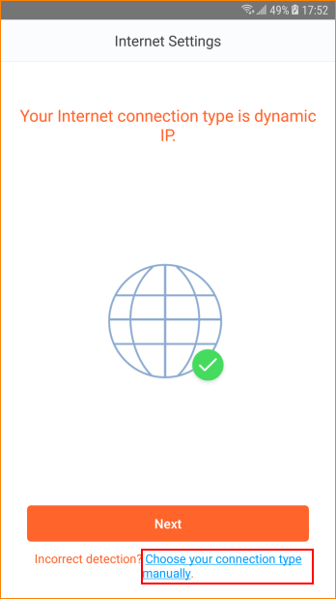

Step 2: Select “PPPoE”

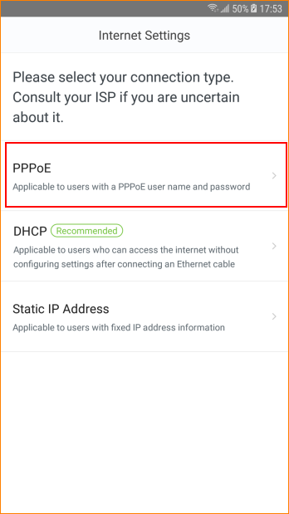

Step 3: Enter ISP user name and password, tap “Next”. If you forget ISP account and password, please ask ISP for help.

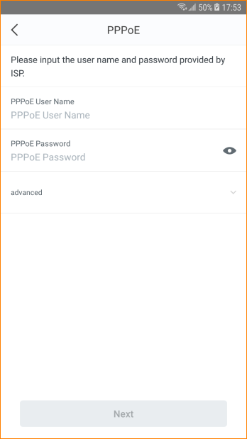

Step 4: Follow the instruction to finish the remaining settings.

